To Safe Sender CEC In Outlook (desktop version)

Right click on any email and sect “Junk>Junk Email Options”
On the second tab of the pop-up (Safe Senders) add the following domains
@connectedcommunity.org
@exceptionalchildren.org
@multibriefs.com
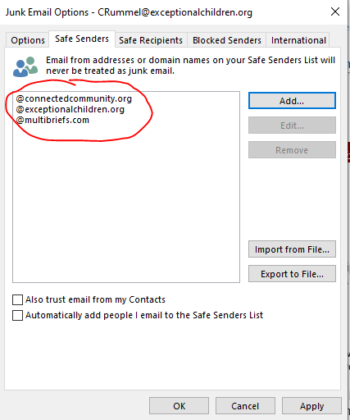
If your email provider requires specific email address be added to safe sender please add to safe sender the following: mail@connectedcommunity.org, service@exceptionalchildren.org, and cec@multibriefs.com.

If your school or university has its own spam filters, you may need to forward this to technical support to request that these domains be added to your Safe Sender list. For additional information, technical support can contact Chad Rummel (crummel@exceptionalchildren.org) 703-264-9404.

