TED 2022 Call for Proposals

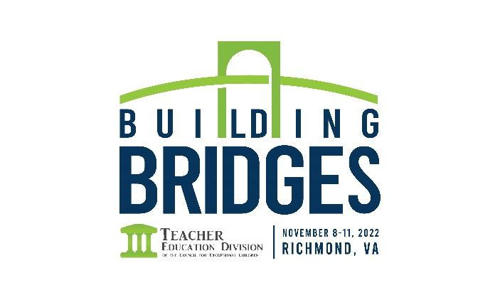
We are very excited for TED 2022! This year we have made some changes to our forms and in the hopes of helping to alleviate any questions we have created this guide on the steps to take to submit for TED2022. However, if you have any questions, please email ted@exceptionalchildren.org

**** With space limited in 2022, only a small percentage of our highest-rated single paper sessions will be accepted. All single session submissions will also be considered for multiple session types- unless specifically requested not to on the form****

TED Collaboration Zone
Prior to Submission we also suggest you use our new collaboration zone to find a presenter to submit with. You complete a brief form about your topic and interests. Once you submit you will get access to a report that shows all other submissions and ways to contact those individuals if you are interested in collaborating with them/ submitting together! View Form Here

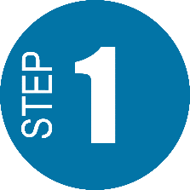Select the Correct Form
Abstract Submission Form- Use this form if you are submitting a session for TED on behalf of yourself/a group
Meetings Form- Use this form if you are submitting to have a meeting at TED (not programming). A general business, executive, or reception.
Kaleidoscope Form- This form is meant for students. All students currently enrolled in doctoral programs are required to submit a proposal to Kaleidoscope as their first submission. If a student does not submit their proposal to Kaleidoscope, they will be required to register at the regular rate.
Special Session Form- Use this form if you are submitting a session for TED on behalf of an affinity group (caucus, SIG, Committee, Affiliate Group, etc.)

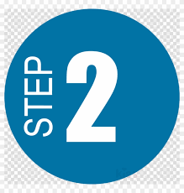Review The Form Requirements
Abstract Submission Form
Below are the questions asked on the TED 2022 Abstract/Proposal form, this is for your reference of what to expect when filling out. You must go here and complete the form online to be considered.
Presentation Title: (Limit 12 words or less)
Topic: Select the Topic that your presentation falls under
- Activism/Advocacy
  - Examples: Building Bridges with Degree Programs for College Students with Disabilities, Building Bridgets through Faculty Activism
- Diversity
  - Examples: Building Bridges with Culturally Responsive Pedagogy, Building Bridges by Facilitating Diversity Discussions
- Partnerships
  - Examples: Building Bridges through Partnerships with Schools, Building Bridges with Collaboration Across Disciplines, Building Bridges with Outside Agencies
- Preparation, Certification, Induction
  - Examples: Building Bridges from In-Person to Virtual Instruction, Building Bridges in Assessing Field-based Experiences, Building Bridges by putting HLPs in Action, Building Bridges to Navigate Accreditation, Building Bridges with Early Career Mentoring Programs
- Policies and Practices
  - Examples: Building Bridges from Early Career to Promotion & Tenure, Building Bridges from Recruitment to Retention
- Research and Inquiry
  - Examples: Building Bridges with Action Research, Building Bridges with Evidence-Based Practices
- Technology
  - Example: Building Bridges for Access through Assistive or Instructional Technology
Presentation Type:
- Single Paper Session
Single paper sessions may be program descriptions or qualitative/quantitative research papers. This presentation format focuses on a significant issue in teacher preparation representing a strong, unifying theme and includes opportunities for audience participation. These sessions are 50 minutes in length, with approximately 35-40 minutes for presentation and 10-15 minutes for discussion. Presenters will be provided a projector, screen, and outlet. Single paper sessions are open to all attendees. With space limited in 2022, only a small percentage of our highest-rated single paper sessions will be accepted
- Multiple Paper
Multiple paper sessions feature up to three authors presenting abbreviated versions of their research, followed by audience discussion. Multiple paper sessions are 50 minutes in length and will be assigned one of two ways. 1. By conference chairs based on topical similarity or 2. If you have already found others you want to submit with either on your own or through the collaboration zone, select this session type. The typical structure for a session includes three papers with approximately 5 minutes for the chair’s introduction to the session, 10 minutes per author presentation, and 15 minutes of comments/discussion. Session chairs may adjust the timing based on the number of presentations and discussants scheduled for the session. Individuals must be attentive to the time allocation for presenting their work in multiple paper sessions. In the case of multiple-authored papers, more than one person may present, but presenters are urged to be attentive to the total time available to them so that allowing more than one speaker does not detract from the overall presentation of the work or keep others from presenting their work.
- Quick Chats
Quick Chat Sessions are 50-minute, fast-paced, dynamic sessions on a single topic with four speakers; each presenter has 10 minutes to present up to 10 slides. Ten minutes at the end of the session will be open for questions and discussion. Presenters will be provided a projector, screen, and outlet. One person from the group of presenters will be asked to serve as organizer/moderator by the Conference Advisory Committee
- Conversation Tables
Conversation Tables are 50-minute, interactive sessions with three round tables, with discussion leaders at each table. Participants will rotate every 15 minutes, with the opportunity to each of the 3 tables during the session. A non-presenter will be asked to serve as session organizer/moderator by the Conference Advisory Committee.
- Interactive Poster Session
Interactive Poster Sessions combine a graphic display of research with the opportunity for individualized, informal discussion of the research throughout a 50-minute session. Each Interactive Poster Session has approximately 10 posters, with individual presenters displaying posters representing their papers in a large area with other presenters. There is no AV support for Interactive Poster sessions. Interactive Poster sessions are open to all attendees

Abstract : Provide an abstract for use in the schedule (50 words or less)
Objectives and Audience (250-word limit)
Session objectives are clearly stated and supported by the information provided in the proposal; objectives are targeted to an audience of teacher educators
Significance and Productive Outcomes (500-word limit)
The proposal provides a description of the significance of the topic and how the presentation will lead to productive outcomes for teacher educators, teacher candidates and/or students with disabilities from a variety of backgrounds (e.g., considerations for culture, gender, language, race, ethnicity, religion, sexual orientation, socio- economic status, and diverse abilities)
Alignment with Conference Theme (250-word limit)
The proposal clearly describes how the proposal content aligns to the conference theme: Building Bridges.

Current Research Base (1000-word limit)
The proposal includes ties to the current research by providing a clear description of the evidence supporting the practice, content, or outcome OR a description of how the presentation will add to the evidence-base.
MUST Include citations, not a reference list
Presentation Plan and Methods of Audience Participation (500-word limit)
Presentation plan is well organized; includes description of audience engagement methods and multiple means of representation, as well as a description of how materials and content will be accessible to members in the audience. Correct use of grammar, usage, of mechanics.
Presentation Focus- Select the area of focus your presentation falls under
Promising Practice:
• Shown to have positive effects on learner outcomes
• The research design does not clearly demonstrate that the practice led to child or student improvement
• Insufficient number of studies conducted to demonstrate its effectiveness
Research-Based Practice
• Some research studies have demonstrated positive effects on student outcomes while other studies have not
• Based on research that may or may not clearly demonstrate that the practice led to an improved child or student outcomes
• Multiple studies have been conducted
Emerging Practice
• Anecdotal evidence of effectiveness
• Research has not been conducted

Special Sessions Form
Below are the questions asked on the TED 2022 Special Sessions form, this is for your reference of what to expect when filling out. You must go here and complete the form online to be considered.
Committee/Group Name : Name of the SIG, Caucus, Committee, etc that you are submitting this proposal for
Session Type:
- Symposium/Panel/Spotlight Session This submission type will be used to get all of your special session types in the scheduler. A symposium or special session allows participants to examine specific issues or topics from a variety of perspectives.
- Round Tables This session type would be something that involves the need for round tables and discussion.
- Working Group Session (time varies; classroom set up)
Working group roundtables encourage substantive exchange and interaction among researchers working on a common set of research issues, problems, or themes. Participants in these sessions discuss areas that are cross-cutting, where there are shared research problems or issues that would benefit from cooperation and exchange, or where researchers with complementary interests would benefit from new, synergistic discussions. Committees, caucuses, and SIGs may propose these Working Group Sessions for consideration of the conference chair's approval, based on space and programming needs. AV is not available for Working Group Sessions.
- Invited Session
Invited Sessions are used at the request of the Committee, Caucus, SIG Chairs, the TED Presidential Line, or the Conference Advisory Committee to include dynamic speakers in the conference program.
- Panel
Panel presentations focus on a significant issue in teacher preparation representing a strong, unifying theme and including opportunities for audience participation. These may include but are not limited to program descriptions, multiple perspectives on important issues in teacher preparation, or descriptions of IHE/school partnerships. These sessions are 50 minutes long, with approximately 35-40 minutes for presentation and 10-15 minutes for discussion/ questions. It is the responsibility of the person submitting the proposal to invite the panel participants, to ensure all names are included in the submission and moderate the session. Presenters will be provided a projector, screen, and outlet.

Description for Program: ( 50 words or less)
Significance and Productive Outcomes: The proposal provides a description of the significance of the topic and how the presentation will lead to productive outcomes for teacher educators, teacher candidates and/or students with disabilities from a variety of backgrounds (e.g., considerations for culture, gender, language, race, ethnicity, religion, sexual orientation, socio- economic status, and diverse abilities) ( 500 word limit)
Length of Programming: Our normal session length is 50minutes, please indicate how long you need for this session
Primary Avoidances: Please detail any sessions you would like to avoid conflicting with, this is not promised. You can also include Days/Times you wish to avoid- again nothing is guaranteed, but the conference chair will take into account when possible. ( Put your top priority as Priority 1)
Meeting Form
Below are the questions asked on the TED 2022 Special Sessions form, this is for your reference of what to expect when filling out. You must go here and complete the form online to be considered
Committee/Group Name : Name of the SIG, Caucus, Committee, etc that you are submitting this proposal for
Description for Program:
Invite Only: If you want this meeting to be marked as invite only check this box
Meeting Type:
Select the type of meeting or event below . If you are having an event that is offsite that you would like promoted in the program, please select that.
Board Meeting
General Business Meeting
Group Meeting
Reception
Auction
Off-Site Event
Length of Meeting: Our normal session length is 50minutes, please indicate how long you need for this session
Primary Avoidances: Please detail any sessions you would like to avoid conflicting with, this is not promised. You can also include Days/Times you wish to avoid- again nothing is guaranteed, but the conference chair will take into account when possible. ( Put your top priority as Priority 1)

