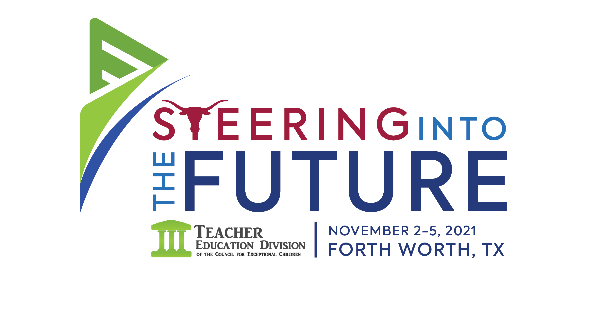
The Executive Board of the
Teacher Education Division of the Council for Exceptional Children
invites you to submit proposals for the
43rd TED Conference
Ft. Worth, TX
November 2-5, 2021
Deadline: JUNE 1, 2021

Theme: Steering into The Future

Topical Strands

Accountability/Assessment: Teacher evaluation, program evaluation, evidence-based programs, assessment
Diversity: The recruitment, retention and development of teachers who reflect the diversity of the human experience: cultural, disabilities, gender, linguistic, LGBTQIA, and/or racial diversity
Collaboration/Partnerships: Collaboration and partnerships with families, special education, and general education
Preparation, Certification, Mentoring: Pedagogy, mentoring, professional development, retention of teachers
Policy, Advocacy, Activism: Policy analysis, advocacy and activism, legal issues
Research: Highly effective educational practices, preparation of special and general education teachers, bridging the research to practice gap
Technology: Modeling and assessing technology used in teacher education as well as in PK-12 classrooms
High Leverage Practices: How do we teach HLPs, How do we represent HLPs, How do we show deliberate practice in teacher education?

Session Types
Single Paper Session
Single paper sessions may be program descriptions or qualitative/quantitative research papers. This presentation format provides focus on a significant issue in teacher preparation representing a strong, unifying theme and includes opportunities for audience participation. These sessions are 50 minutes in length, with approximately 35-40 minutes for presentation and 10-15 minutes for discussion. Presenters will be provided a projector, screen, and outlet. Single paper sessions are open to all attendees. The conference planning committee may combine proposals with related topics submitted as single papers to form multiple paper or topical roundtable sessions. Decisions for such changes will be based on the reviewer's scores of proposals.
Multiple Panel Session
Multiple panel sessions may be program descriptions, multiple perspectives on issues in teacher preparation, or descriptions of IHE/school partnerships. This presentation format provides focus on a significant issue in teacher preparation representing a strong, unifying theme and includes opportunities for audience participation. These sessions are 50 minutes in length, with approximately 35-40 minutes for presentation and 10-15 minutes for discussion/questions. It is the responsibility of the person submitting the proposal to invite the panel participants and ensure all names are included on the submission. Presenters will be provided a projector, screen, and outlet. Multiple panel sessions are open to all attendees.
Conversation Sessions
Conversation Sessions offer up to 10 tables focused on different topics, with each table having a single topic for discussion. No AV support is provided for Conversation Sessions. Conversation Sessions are open to all attendees.
Interactive Poster Session
Interactive Poster sessions combine a graphic display of research with the opportunity for individualized, informal discussion of the research throughout a 50-minute session. Individual presenters set up displays representing their papers in a large area with other presenters. Each poster session has roughly 10 posters. No AV support for Interactive Poster sessions.
Demonstrations/Workshop
Demonstration/performance sessions are for showing or illustrating a particular technique, tool, or method to convey the value of the approach for research or to illustrate or present understandings or findings through such a method. Presenters will be required to pay a $1000 sponsor fee for a 50-minute session and $1500 for a 110-minute session. AV support for Demonstrations and Workshops includes a projector, screen, and outlet. Demonstrations are open to all attendees. If a proposal for a demonstration/workshop is accepted, the primary presenter will be contacted with information regarding payment.
Proposals
Proposals should be related to the conference theme. Abstract; session description, including a review of relevant literature and aim of the session; three to five learner outcomes based on the aim and objectives of the session; and a description of audience participation must be included. Do not include names or institutional affiliation in the summary of the proposed presentation. Session leader is responsible for communicating with all co‐presenters regarding registration and presentation times.

Selection Criteria
Review of proposals is a peer-reviewed process; the review team will use the following criteria in the selection of proposals.

Description of the research or applied problem (clarity and importance)
Presentation summary (clarity and organization)
Literature review, methods and findings (alignment of literature with content, extent to which the research informs the field)
Usefulness to teacher preparation researchers and practitioners (meaningful audience participation and outcomes related to improved practice.)

The reviewers will consider, where appropriate, acceptance of presentation proposals outside the conference theme based on their overall quality. Session leaders will be notified of acceptance by August 15, 2021.
Program Participation
To encourage broad program participation, as per TED policy, an individual may only be included as a primary presenter or session leader for TWO sessions, and co-presenter for TWO sessions. An individual may in the program as a presenter or co-presenter for up to four times in total. Presenters are expected to be involved in and attend all sessions in which they are presenting or co-presenting.

Inclusion in TED 2021 Program
All presenters and co-presenters must register and pay conference registration fees, travel, and other expenses. As per TED policy, to be included in the program, each presenter’s conference registration must be received by September 15, 2021, or name(s) will not be included in the conference program.

Questions? Need More Information?
Contact the TED 2021 Conference Chair:
Brannan Meyers
ted@exceptionalchildren.org

