How To Have Co-Presenter/ Submit without disclosure

One question we have been getting more is individuals who have completed their proposal but cannot submit. The main reason for this, if they have a co-presenter is because the co-presenter has not yet submitted their disclosure, so please see the steps below on how to fix this!

- The step you are at is the final page, and you want to click submit:

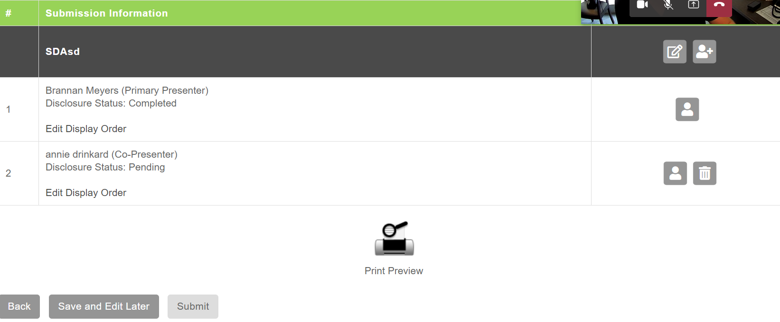

- You will see that the disclosure status of your co-presenter (if they have not already signed a disclosure) is pending, and when you try to submit you will get this :

- Click save and edit later and you will get this :
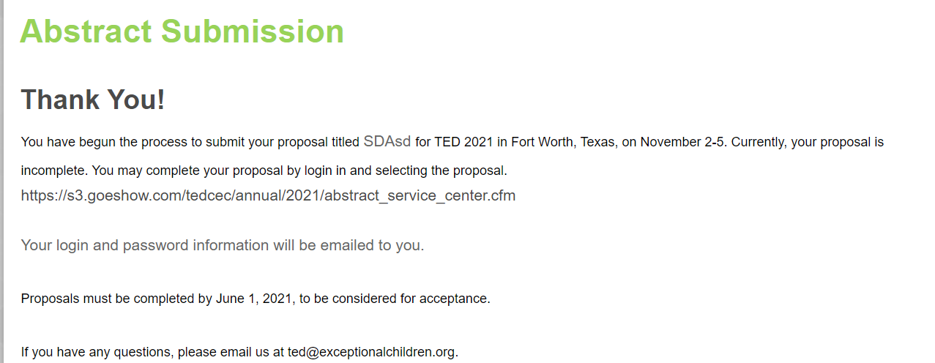

- You and your co presenter (s) will get emails that look like the email below with log in information:
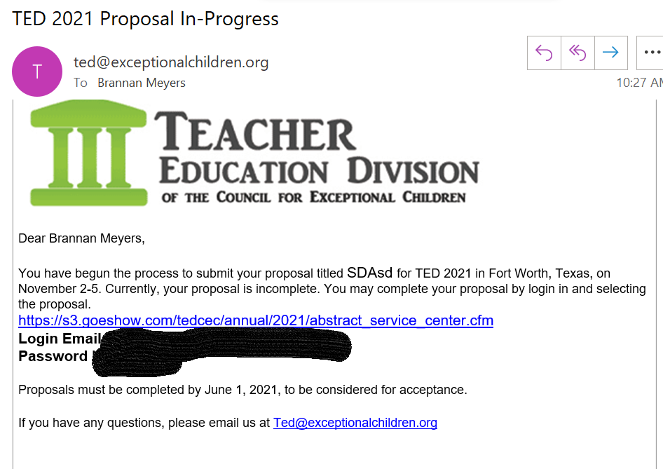

If you don’t receive the above email within 10 minutes please email ted@exceptionalchildren.org and we can re-send the email to you or your co presenter. Once your co-presenter completes the disclosure

- The next step is to log into the link with the email and password provided. The co-presenter will see this:
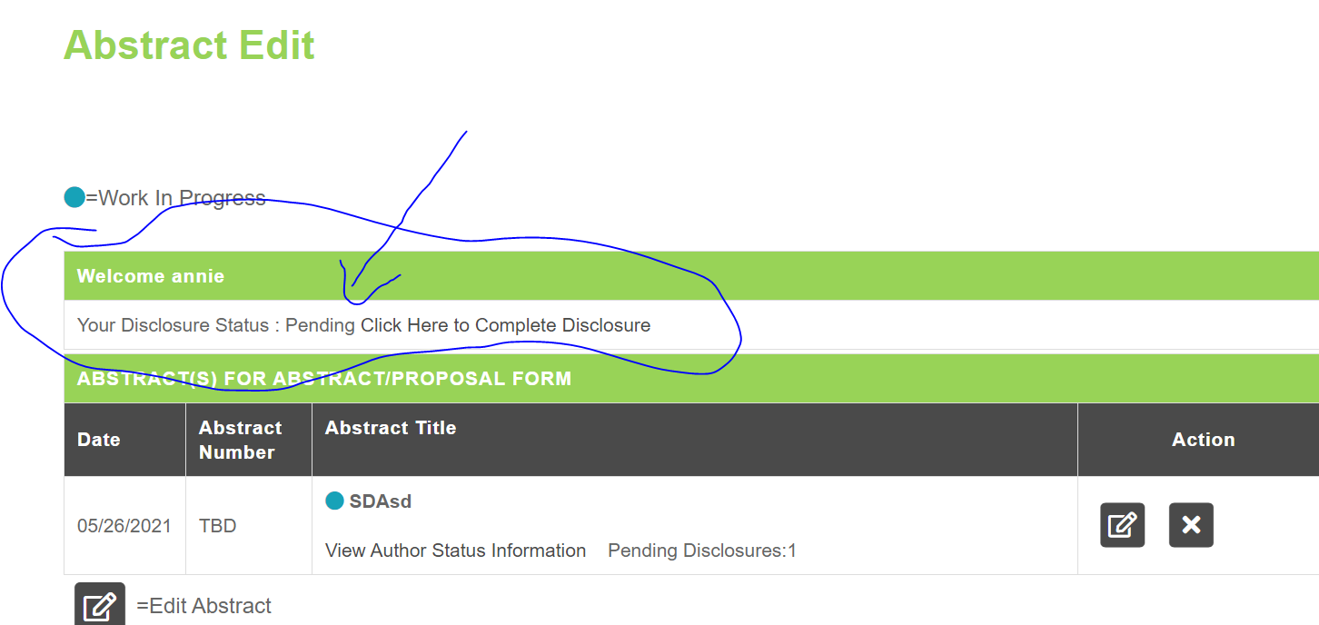

- Once your co-presenter has signed the disclosure you will sign back into the proposal with your log-in information and see this, click the edit abstract button :

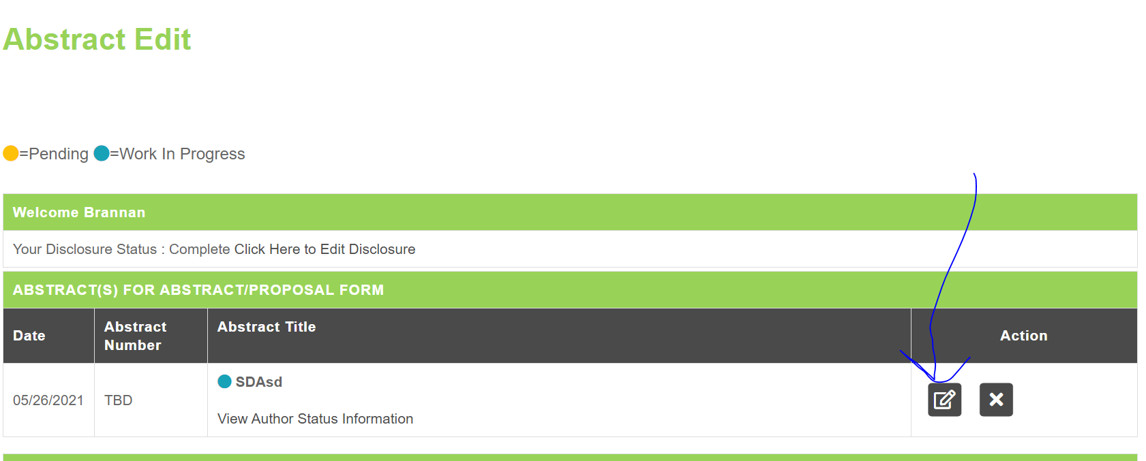

- Now you will see that the disclosure are completed and you can see a submit button, click the submit button and you are done!:

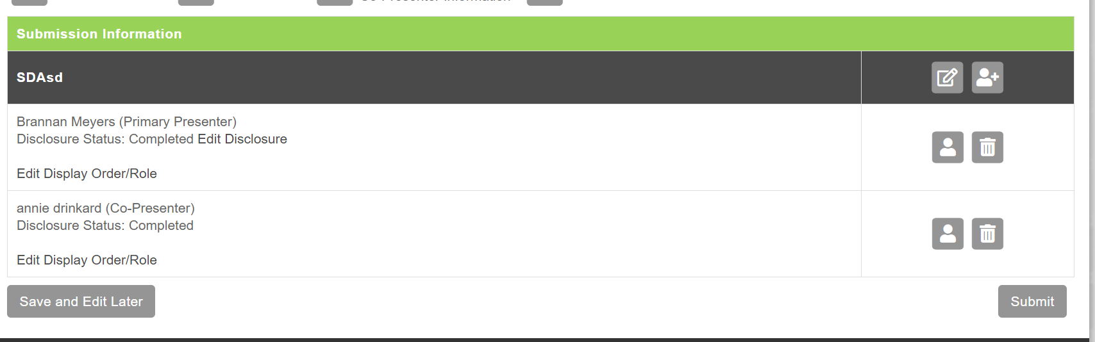

- You will receive an email like below when the proposal is completed
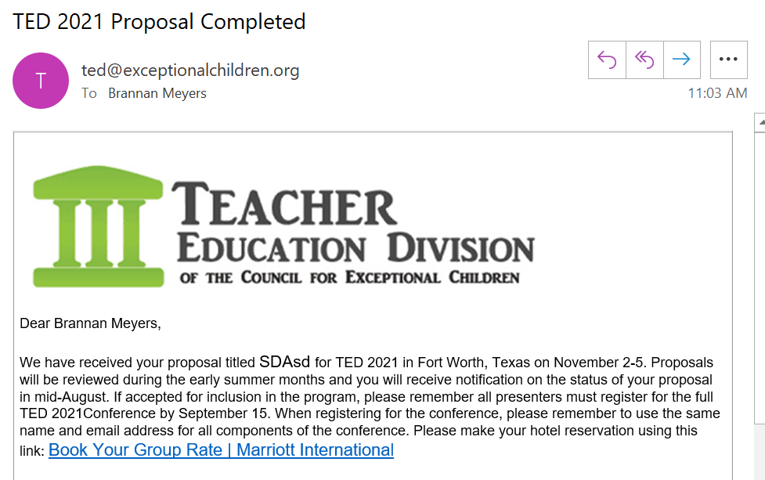

If you have any further questions please email ted@exceptionalchildren.org . Remember all edits must be done by June 1, 2021!

